***MEMORY DUMP EXERCISE***

***USING FTK IMAGER AND PHOTOREC***

***“ACQUIRE MEMORY DUMP OF A WINDOWS SYSTEM WITH FTK IMAGER”***

***“CARVE THE MEMORY DUMP USING PHOTOREC”***

***SUBMITTED BY ADENIKE OLUWABUSOLA ONI***

***FTK Imager Software*** 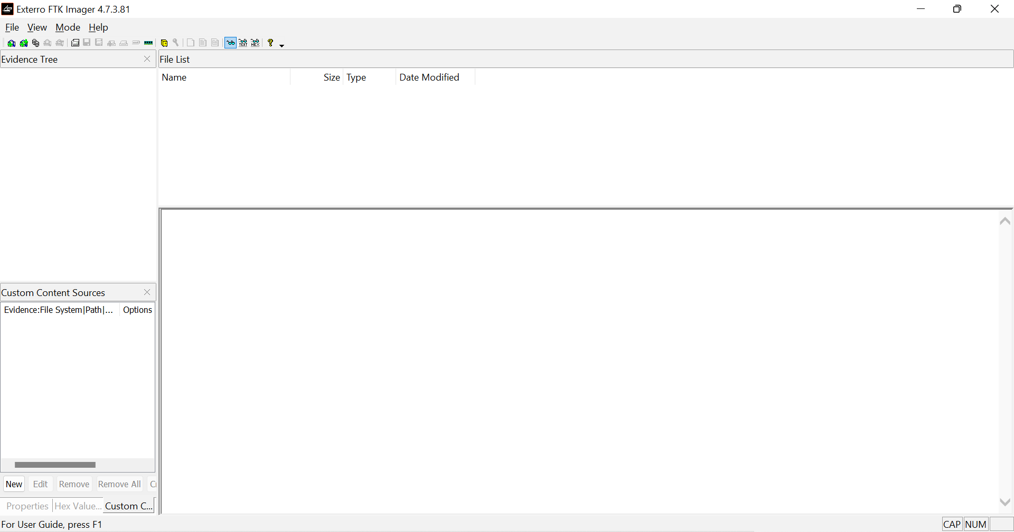

File - Capture memory - Browse destination path - Fill destination file name - Include page file - Capture memory 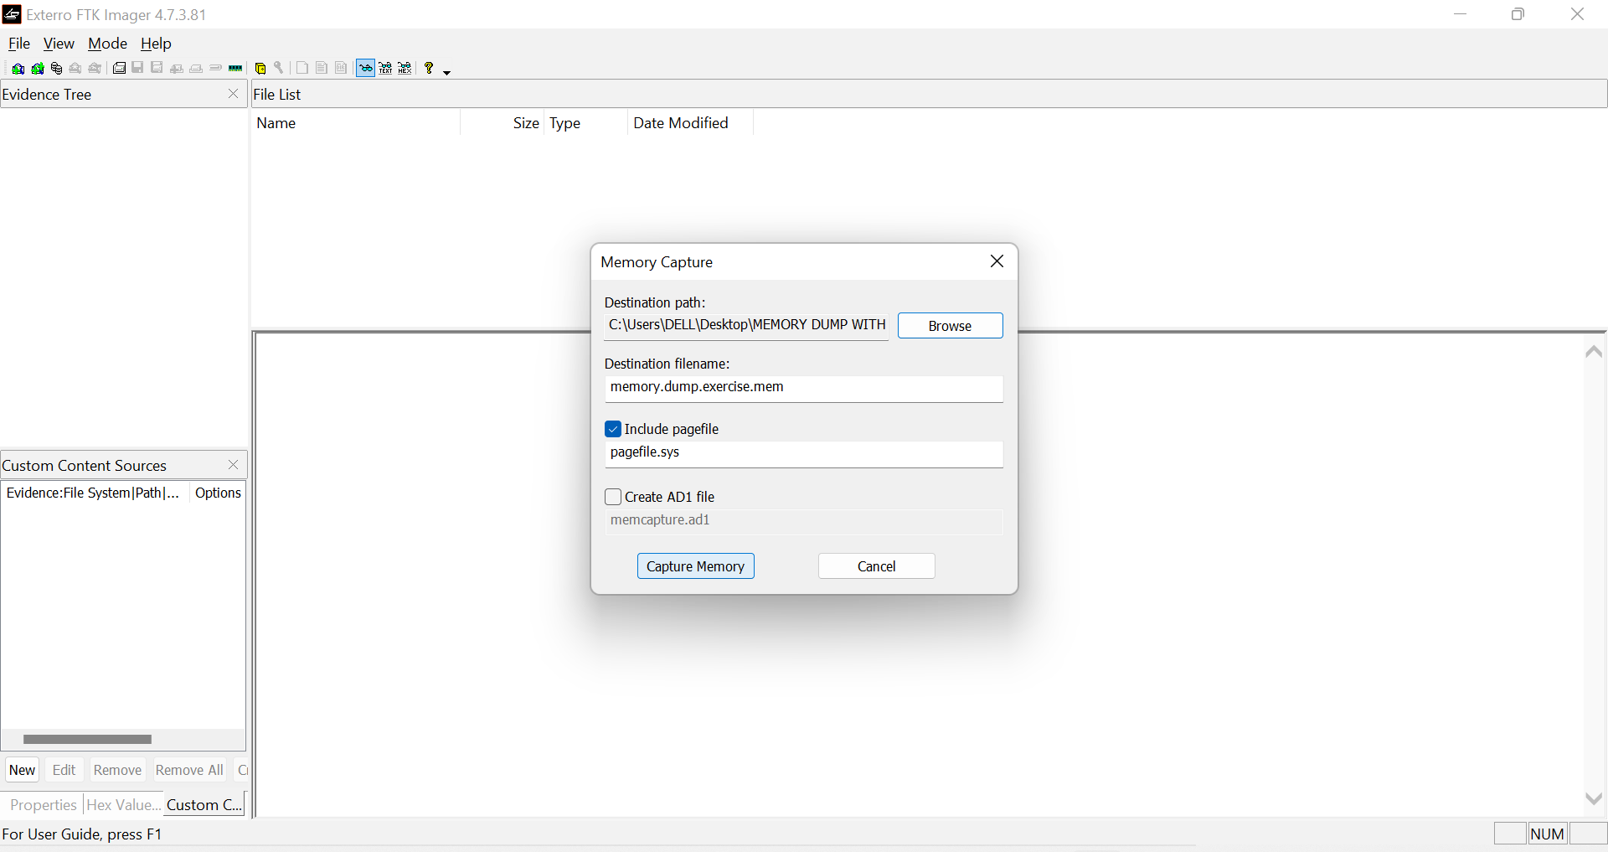

In progress - Completed 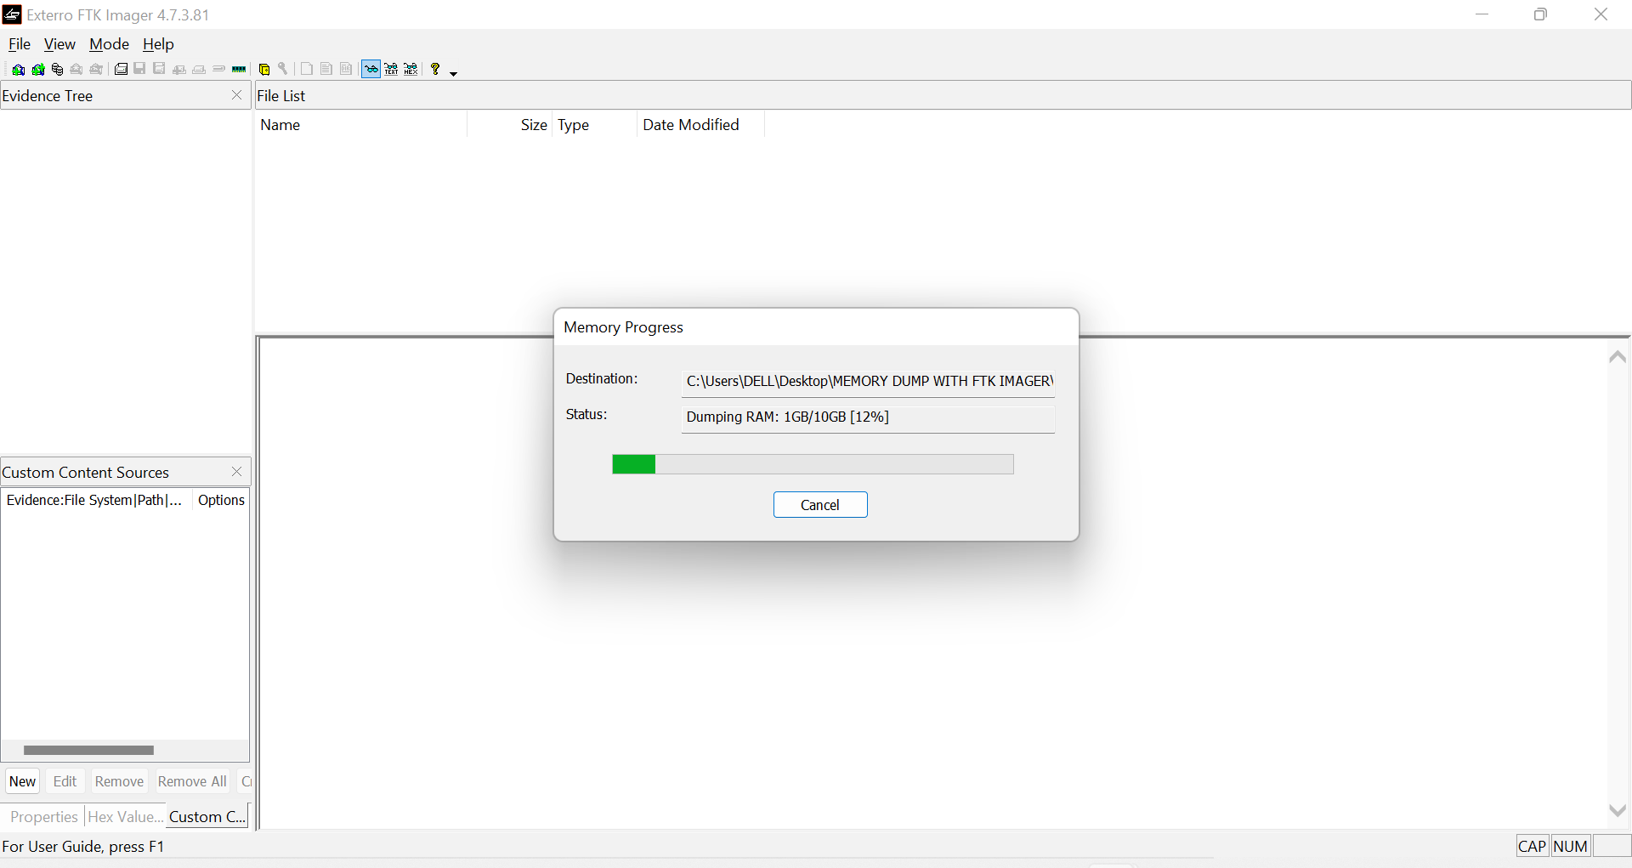

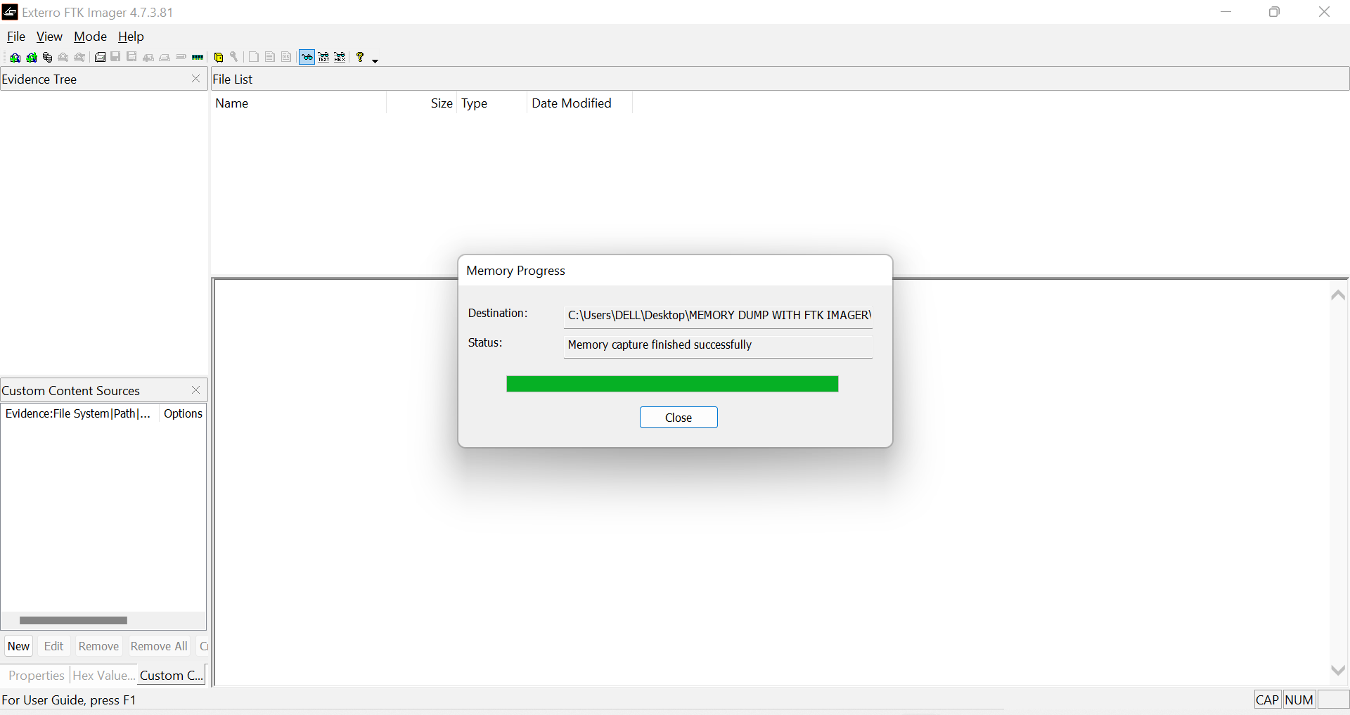

Memory dump file folder

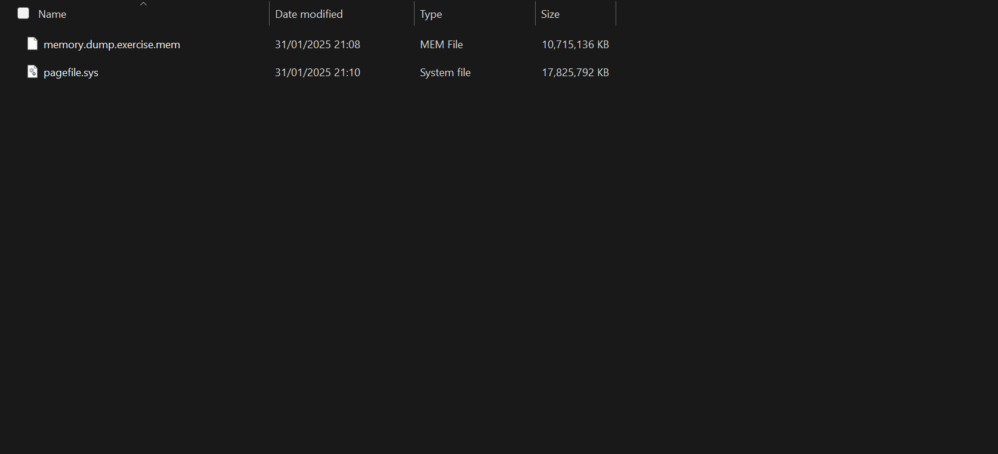

Share folder to access the memory dump in Kali Linux

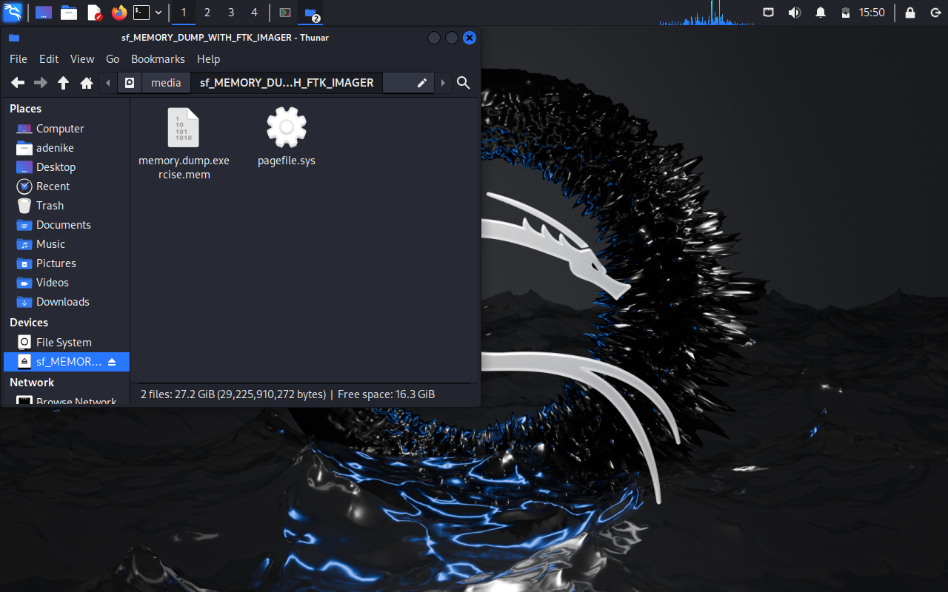

File operation progress - Copy from the shared folder to Kali Linux desktop

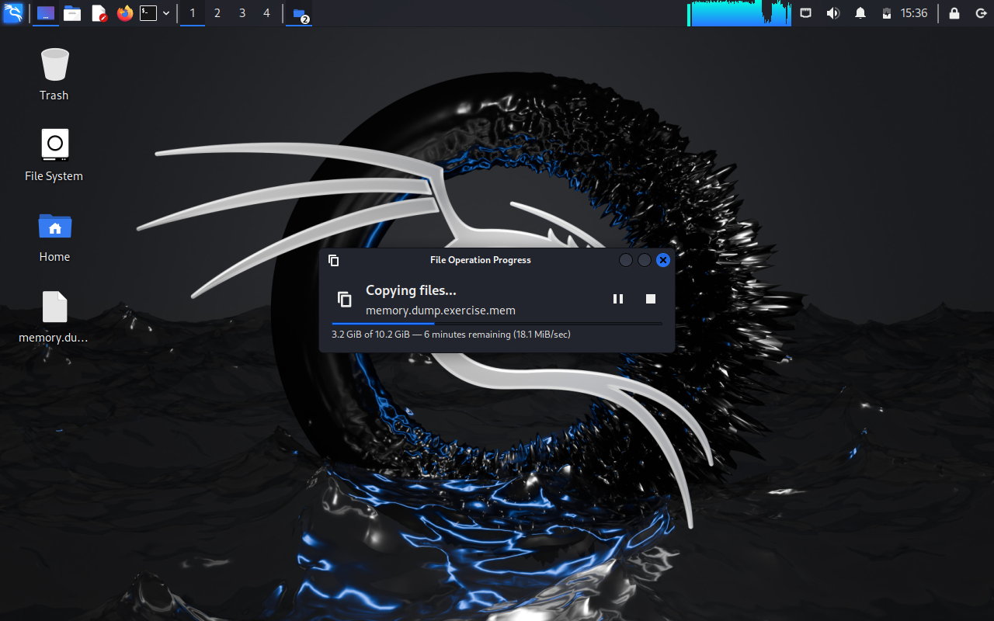

File copied to Kali Linux desktop

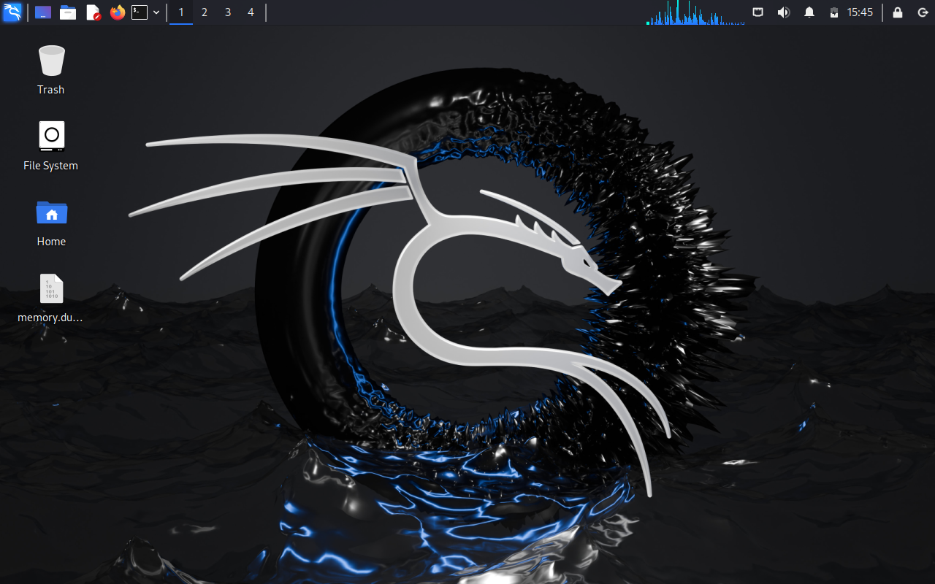

Run terminal to confirm memory dump has been successfully copied to the Desktop

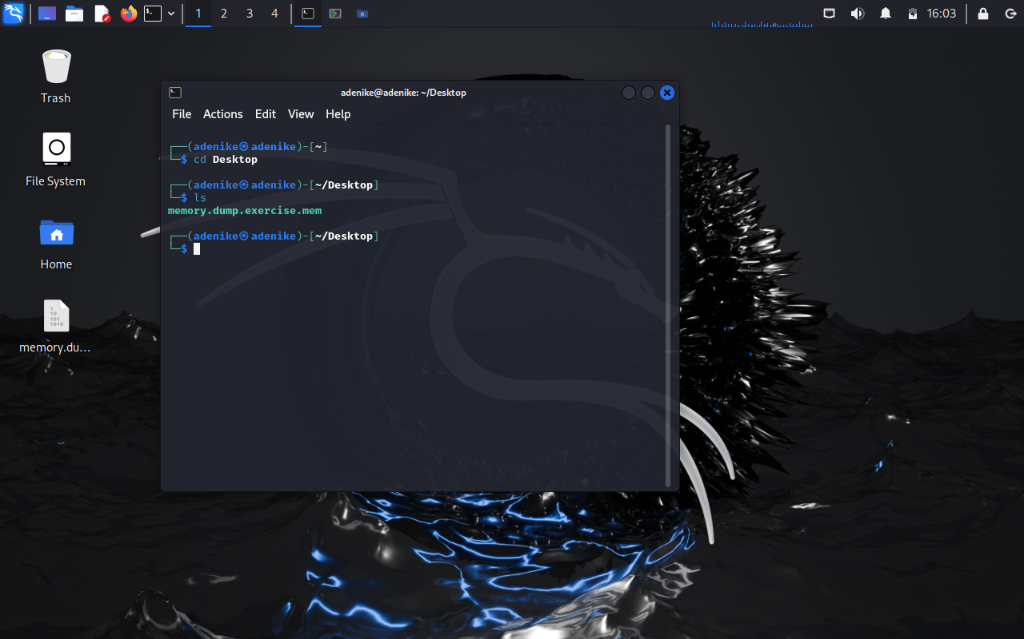

Select destination to carve the memory dump using PhotoRec

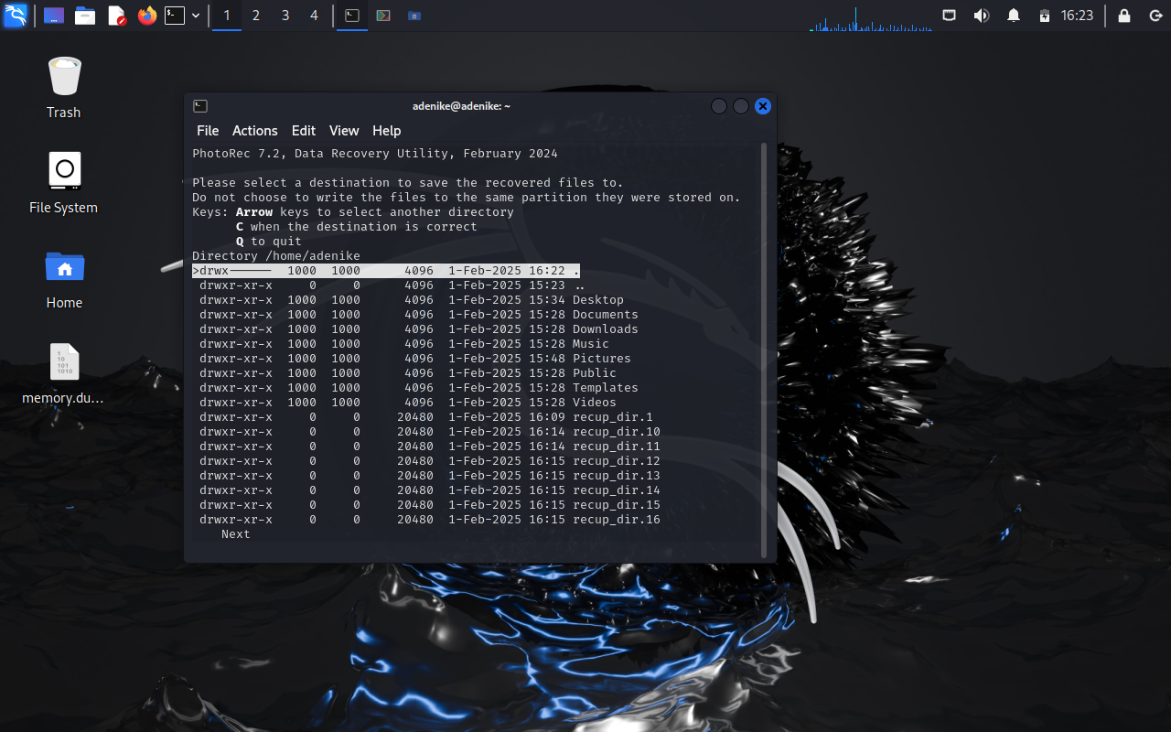

Recovery in progress

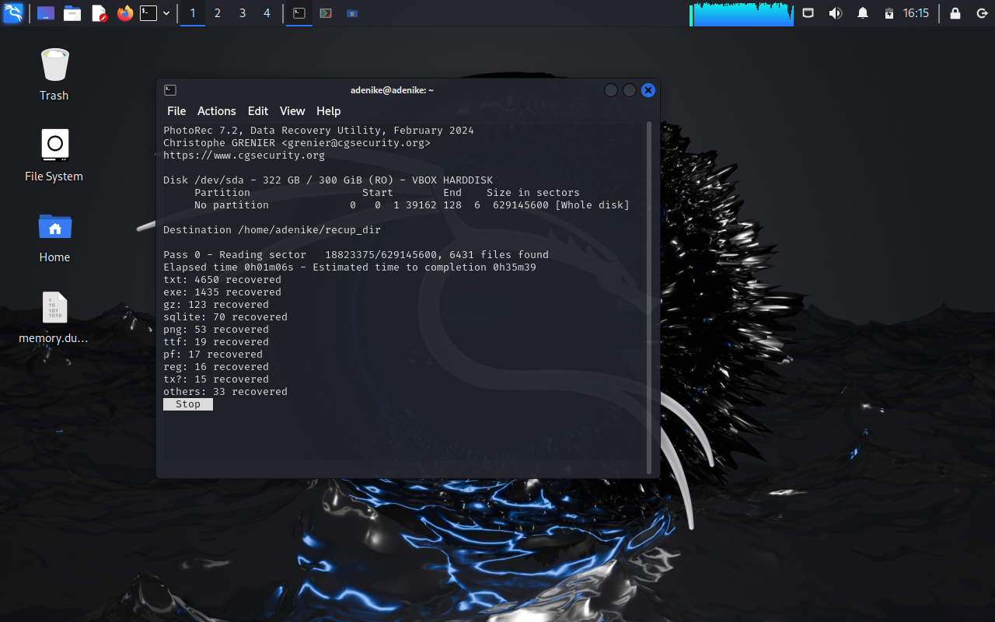

Content of recovered information from memory dump

